

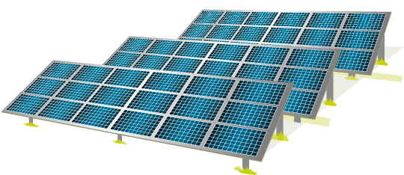



School Grant Fund Criteria
Grant Purpose
The ‘Ferry Farm School Grant Fund’ is a new fund that aims to support projects in local schools that promote environmental education, sustainability and climate action.
With an annual allocation of £5,000, the fund aims to empower schools to deliver impactful projects that inspire students and benefit the local environment. As this is a new fund for 2025, the annual funding allocation will be reviewed based on demand. Priority will be given to projects that provide tangible and long-lasting benefits, which may include, but are not limited to:
- Student engagement & leadership – Funding for student-led citizens’ assemblies and activities that help develop a vision and plans for a net zero future.
- Environmental education – Support for forest schools, nature-based learning and outdoor environmental installations, such as sensory gardens or wildlife areas.
- STEM & sustainability initiatives – Funding for Greenpower kit cars, eco councils and school-wide climate action projects.
- Renewable energy & energy efficiency – Projects that introduce energy-efficient solutions, renewable installations, or sustainability measures within school buildings.
- Efforts to promote sustainable food practices, food-growing or gardening
- Nature conservation projects


Eligibility criteria
- The applicant must be a school or educational institution based in Selsey or Sidlesham or propose a project that benefits students within these communities.
- The project must have a clear environmental, energy-related or sustainability focus and demonstrate a lasting impact on students and the wider community.
- Demonstrate that the project represents good value for money. For capital expenditure projects, applicants should provide at least three quotes for comparison.
- Funding cannot be awarded retrospectively, meaning projects must not have already started or been completed before the application is submitted.
- The funding cannot replace existing funding sources and should not be used for purposes unrelated to the application.

How to apply
- Download and complete our school grant fund application form. The form is available from the Ferry Farm Community Solar website or upon request.
- Submit it to ross@cfrcic.co.uk
- Applications are reviewed quarterly. The application deadlines and review periods will be communicated clearly on the website.
- Successful applicants will be notified within 14 days of a decision.
Grant process
Once we receive your application, we will conduct an initial assessment to check eligibility and ensure all necessary documents are included.
If anything is missing, we may reach out for further details. Applications are only considered complete once all required information has been submitted.
All grant decisions are made at the discretion of Ferry Farm Community Solar’s directors, notwithstanding this guidance.
Successful applications
Upon written notice of a successful application, the applicant will receive a Grant Offer Agreement, which must be signed before funds are released. The funds will be disbursed following the receipt of an official invoice for the project.

Conditions of funding
Promotion and reporting: Successful applicants are expected to actively promote the grant funding received. A grant offer agreement, including reporting requirements, must be signed before the funds are disbursed. All successful applicants must report on the outcomes of the project and demonstrate how the funds were used.
Financial accountability: Applicants must provide feedback and/or receipts to demonstrate how the grant money has been spent. They must demonstrate that the grant has been used solely for the purpose stated in the application.
Changes and variations: If, for any reason, the circumstances change or you wish to vary the way in which you spend your grant, you are required to contact us to request written permission to do so. If your final costs are less than originally estimated, unspent funds must be returned by the end of the financial year, following the year in which it was awarded.
Impact reporting: We encourage recipients to share feedback and images to showcase the impact of their project. These materials help us highlight the positive outcomes of our funding efforts and inspire others to take action. Please include these as part of your final report.
Further help to guide schools through the application process is available. Contact ross@cfrcic.co.uk for more information

About Ferry Farm Community Solar
Ferry Farm Community Solar is a not-for-profit organisation located between Selsey and Sidlesham, West Sussex. Our community solar farm has been generating electricity and income from the sun since 2016, and our surplus income is used to support projects that reduce energy costs and carbon emissions in the local area.
The solar farm is funded through a £5million 15-year loan from Triodos Bank and £1.15million of community investment from a share offer in 2016 and a bond offer in 2020.
The Ferry Farm board hopes to provide support to local schools on their journey to net-zero through various funding opportunities. We also facilitate site visits to our solar farm for schools and provide funding for retrofit assessments.
Previous support for local schools
- In 2017, we awarded a grant to Medmerry Primary School to promote children's reading. We also funded a new playground at Sidlesham Primary School.
- In 2018, we provided funding to Sidlesham Primary School to develop an outdoor learning space for young students and to Seal Primary Academy for a solar dome.
- During the COVID-19 lockdown, we funded 40 brand-new laptops for local schools - The Academy Selsey, Medmerry Primary, Seal Primary Academy and Sidlesham Primary.

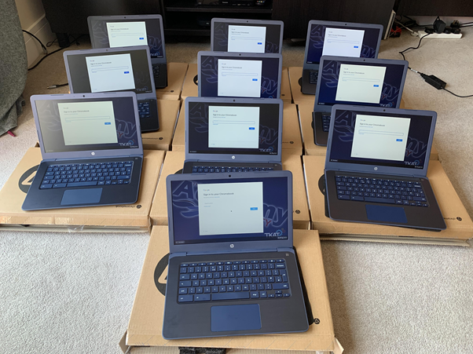

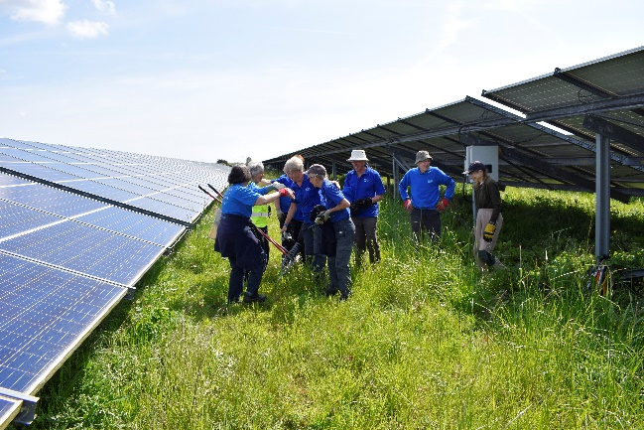

- We also provided access to an electronic reading library for 430 students at The Academy, allowing them to access contemporary reading materials while learning from home.
- In 2022, we awarded funding to Sidlesham Primary School for pond and biodiversity projects.
- In 2024, we sponsored The Academy Selsey’s Green Power Car Project, empowering students to design, build, and race a single-seat electric car.

